TechAbility 2024: Empowering Independence Through Everyday Technology
TechAbility 2024 showcased the transformative power of assistive technology in enhancing the lives of individuals with learning difficulties and disabilities. This year’s event highlighted the experience of learners from The Oaks Specialist College, who ably demonstrated how everyday technology can foster independence and improve quality of life.
The Team

Ethan Sanderson is a second-year learner at the Oaks Specialist College. Ethan has a sense of adventure and enjoys rock climbing, bowling, swimming, and walking. Ethan is a cat lover, and his diverse interests make him ready to take on new challenges and opportunities.
Ethan frequently uses his top apps like Maps, Lens, Microsoft Teams, and various social media platforms to stay connected and organized.

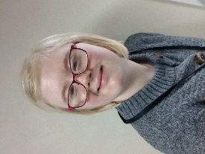
Izzy Marr is an enthusiastic learner at the Oaks Specialist College with a vibrant personality. She has a deep passion for dancing and enjoys listening to her favourite tunes on Spotify. As the middle child, Izzy is very close to her family and loves her role as an aunt.
Izzy also enjoys cooking and relies on the alarms and timer on her phone to ensure her dishes are cooked to perfection.


Libby Wilkins is Assistant Principal at The Oaks Specialist College, where she specialises in everyday and assistive technologies to support young adults with learning difficulties and disabilities. Most recently, Libby has been leading the college’s accessibility offer, sharing her expertise at conferences and has been named a UK Accessibility Fellow by Microsoft for 2023-24.
Libby’s favourite apps are Seeing AI, Google Lens and Maps

Presentation Highlights
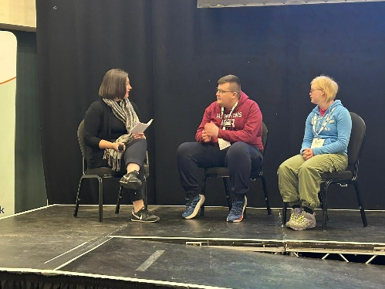
The Oaks team presented “Everyday Technology for Accessibility,” focusing on the use of phone apps to promote independence. Learners created a video interviewing their peers about the most beneficial tech tools in their lives. Izzy and Ethan shared their personal experiences, highlighting how these tools have shifted their reliance from others to self-sufficiency.

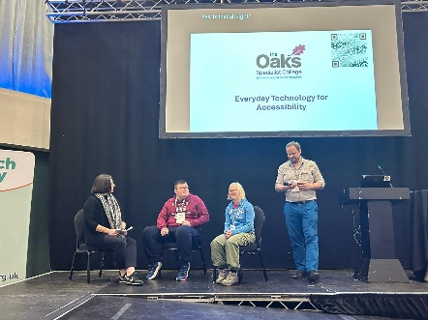
Audience members engaged in hands-on practice with inbuilt accessibility features on their phones, using resources provided for both Android and Apple devices. This interactive session allowed participants to take valuable insights back to their own settings.

Keynote Insights
Keynote speaker Professor Jane Seale highlighted the importance of co-producing resources with users to ensure their voices are represented, enhancing the support practices for adults with learning disabilities. She focused on the use of everyday technology and twice referenced The Oaks Specialist College as exemplifying what should be happening nationally.
Impact on Learners
The event had a profound impact on the learners, providing them with enhanced skills in public safety, communication, meal preparation, personal hygiene, and professional presentation.
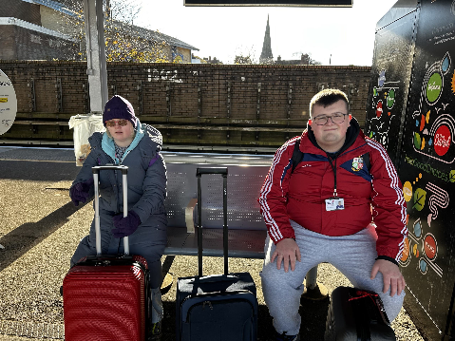
They also gained valuable travel experience, learning strategies for prolonged journeys without family support.
Additionally, they developed practical tech skills through the use of apps like Goblin Tools, Co-Pilot, and the National Rail App. The event offered numerous social and communication opportunities, allowing learners to build relationships, engage in public speaking, and socialize independently.
Furthermore, they contributed to society by participating in paid work, such as interviewing peers for the presentation video.
Libby Wilkins noted, “It is empowering to watch our young people become more independent and train others. The technology we use is a game-changer.”
Impact on The Oaks
The Team benefitted from networking opportunities and exploring new assistive technology solutions. This learning and sharing ideas with others have allowed The Oaks to investigate and explore new assistive technology solutions to better meet the long-term needs of learners.
